IP UART RS232

Uart : 8 bit Universal Asynchronous Transmitter Receiver.
Conversion of parallel into serie.
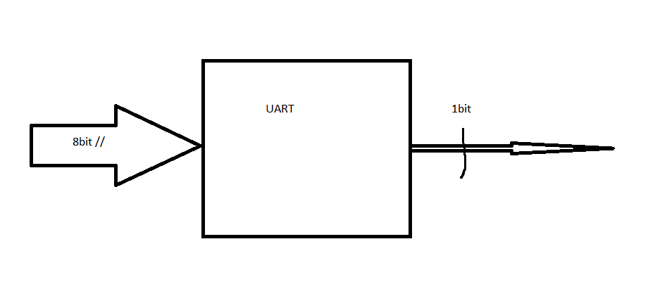
Pas besoin d’horloge en émission ni en réception.

In the UART communication data transmission speed is measured by Baud Rate. Baud rate describes the total number of bit sent through serial communication. It includes Start bit, Data byte, Parity bit and Stop bit. Transmitter and receiver need to be maintained in the baud rate. For example Spartan3 FPGA Image Processing Boardtransmit data at the baud rate of 9600 and at the receiving end PC need to be set with same baud rate using HyperTerminal or TeraTerminal.

